

[My Page](https://www.learn-in-depth.com/online-diploma/mostafaedrees018@gmail.com)

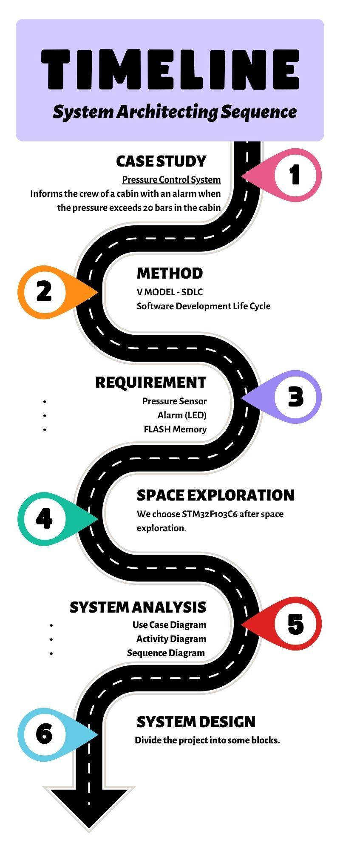

**Pressure Detection System**

**A client expects you to deliver the software of the following system:**

**Specification (from the client):**

* A pressure controller informs the crew of a cabin with an alarm when the pressure exceeds 20 bars in the cabin.
* The alarm duration equals 60 seconds.
* Keeps track of the measured values.

**Assumptions:**

* The controller set up and shutdown procedures are not modeled.
* The controller maintenance is not modeled.
* The pressure sensor never fails.
* The alarm never fails.
* The controller never faces power cut.

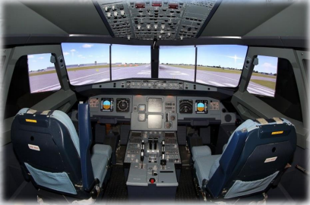

**Version 1.0:**

The keep track of measured value option is not modeled in the first version of the design.

**There are different methods like as:**

* V Model-SDLC
* Waterfall Model-SDLC
* SPIRAL Model-SDLC

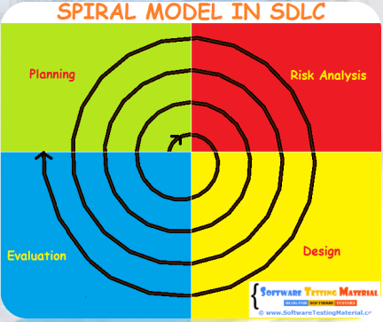

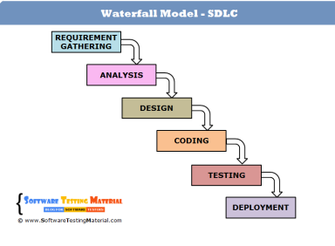

We will use **V Model-SDLC**

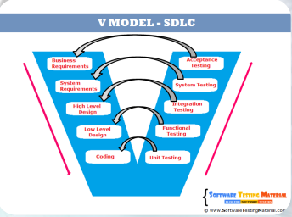

**SDLC** is Software Development Life Cycle.

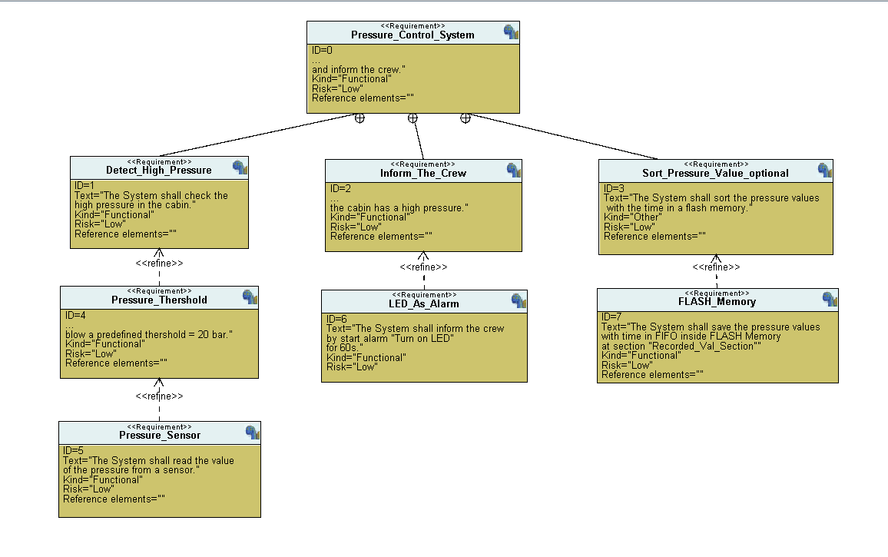

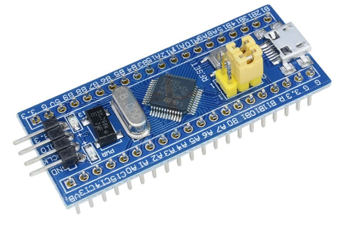  
After space exploration we will use:

**Microcontroller:** STM32F10C6

**Processor:** Arm-Cortex-M3

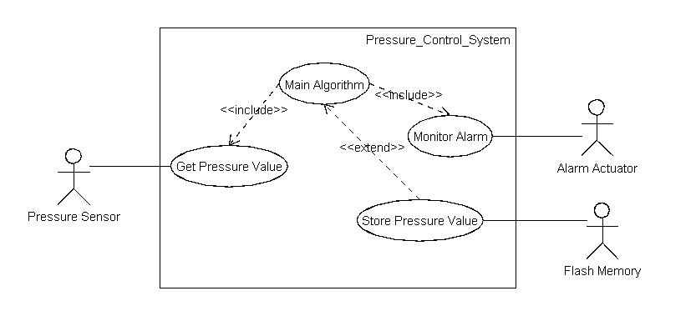It will obtain System boundary and Main functions.

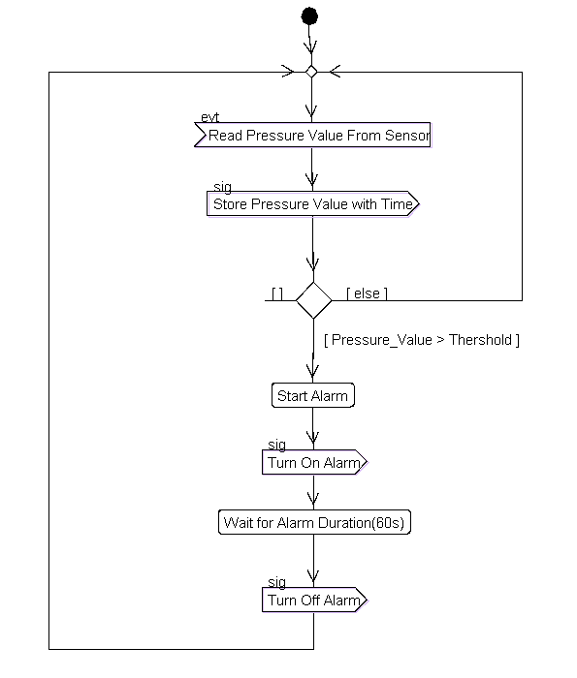It’s used to describe the workflow behavior of a system.

**A sequence diagram is:**

* An interaction diagram that details how operations are carried out.
* What messages are sent and when.
* 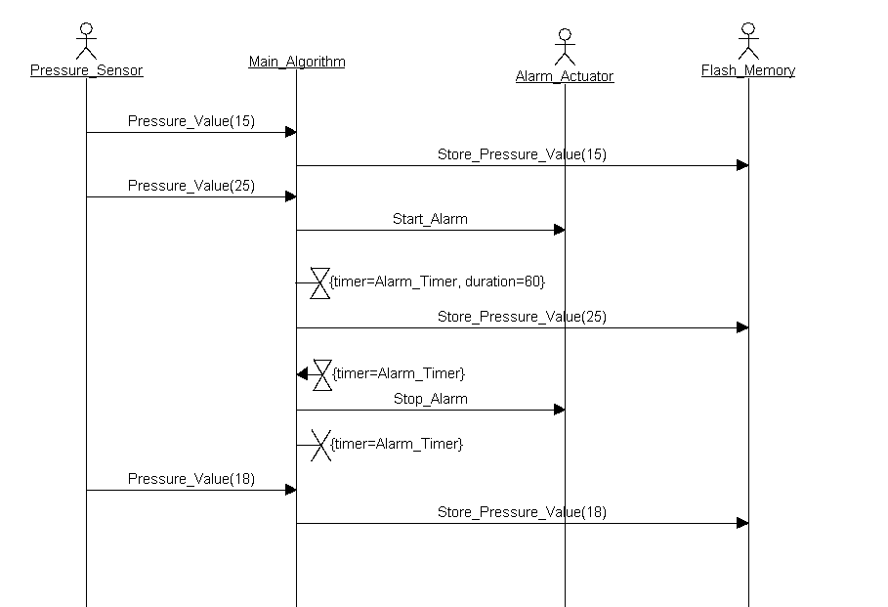Is organized according to time.

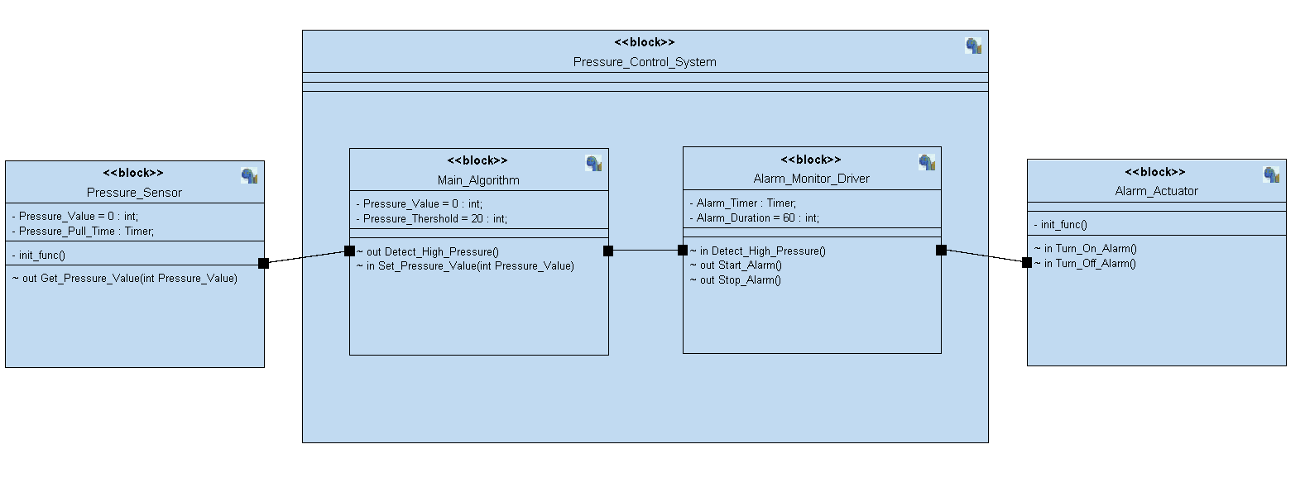

**State Machine for each block:**

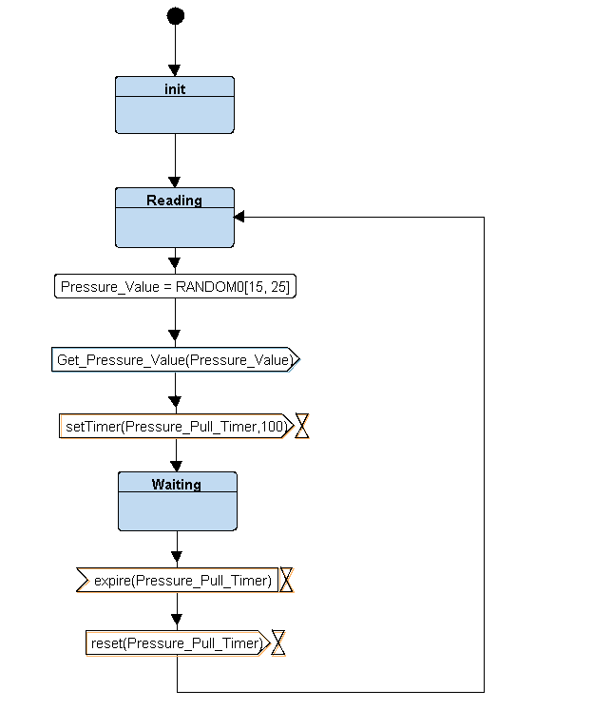 **Pressure Sensor**

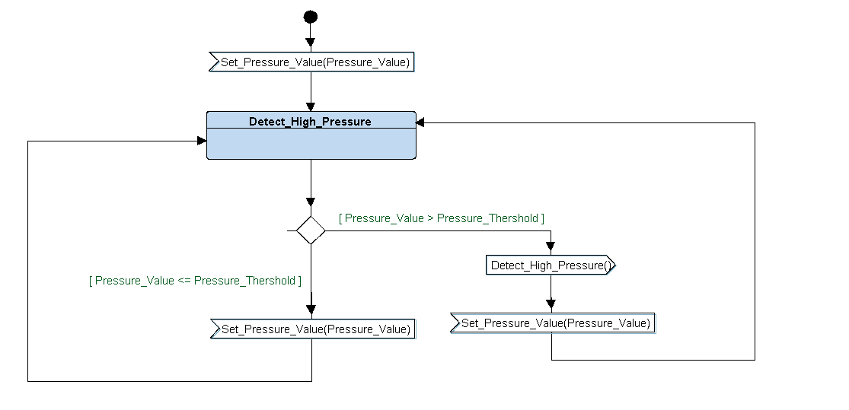 **Main Algorithm**

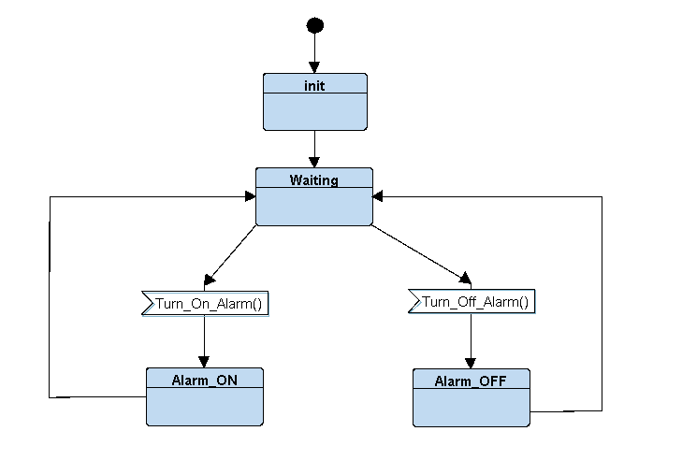 **Alarm Actuator**

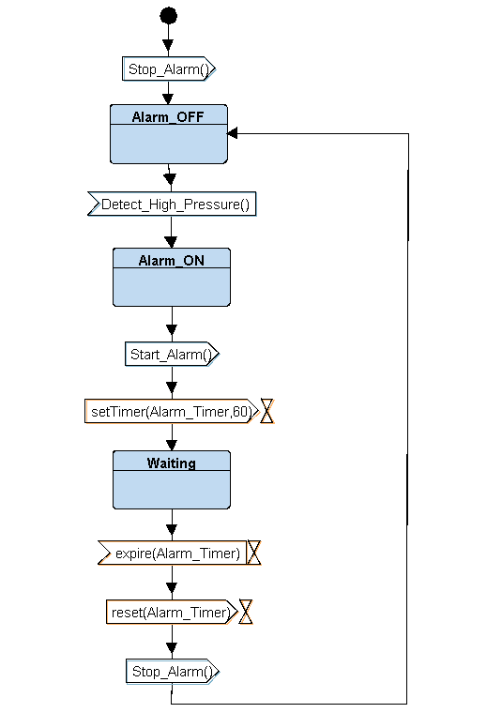 **Alarm Monitor Driver**

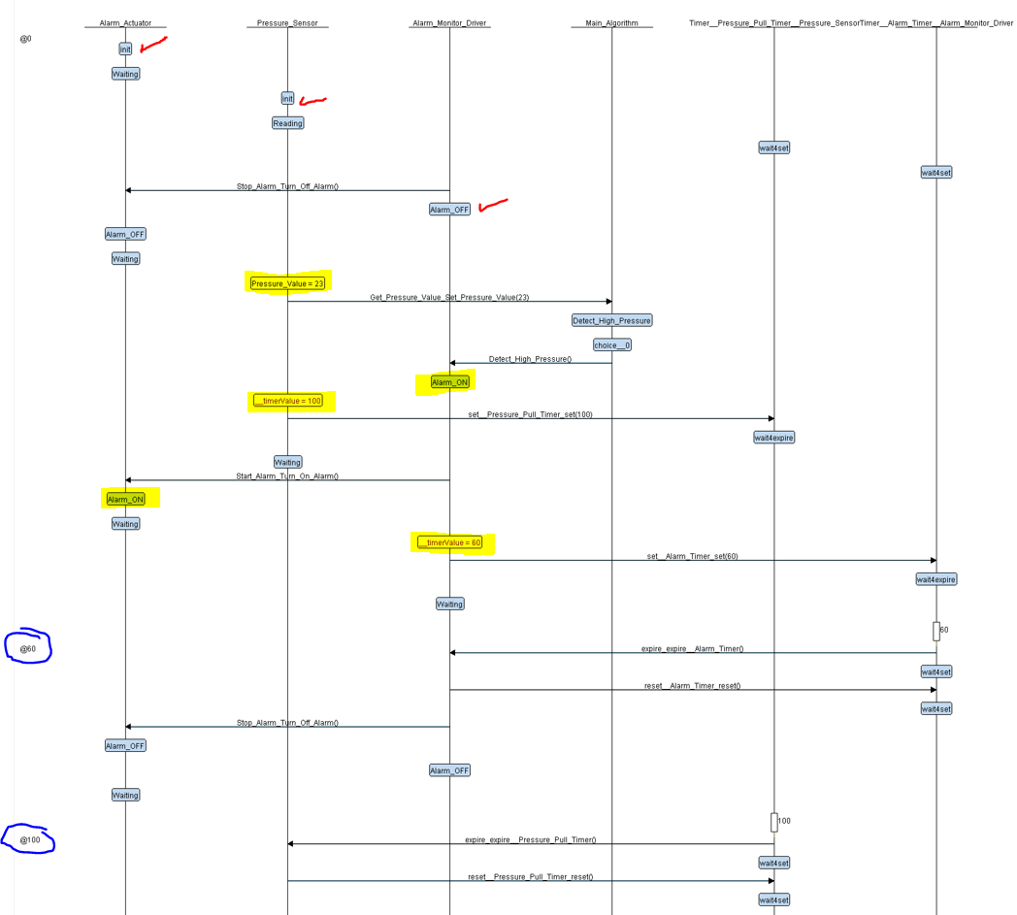**Interactive Simulation State when pressure is bigger than 20:**

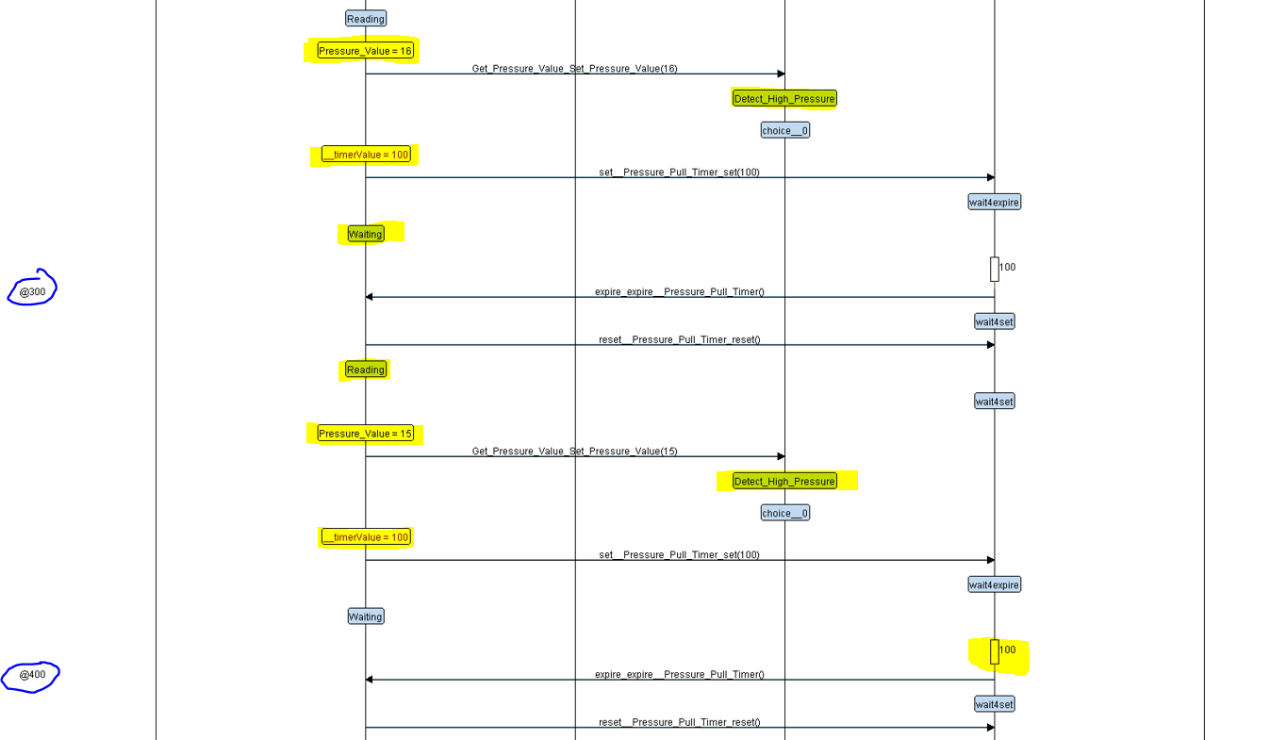**Interactive Simulation State when pressure is smaller than 20:**

The Alarm is not turn on and we don’t use the timer of it because the pressure sensor read values less than 20 bar.

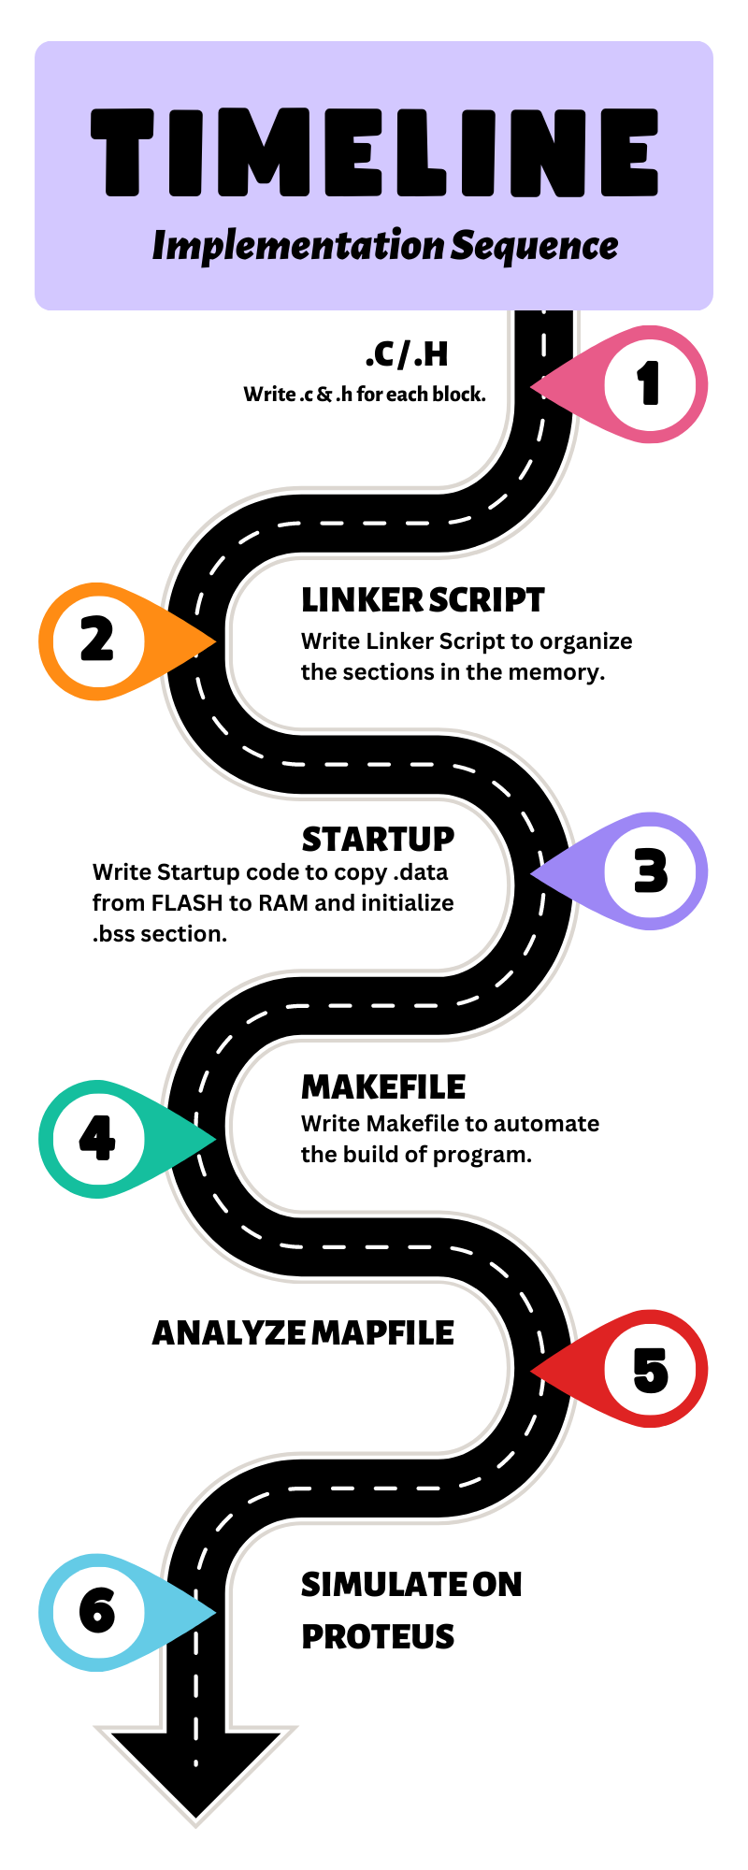

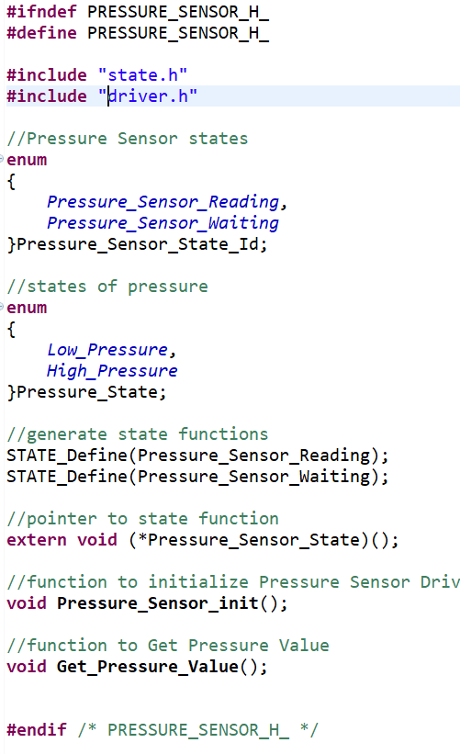

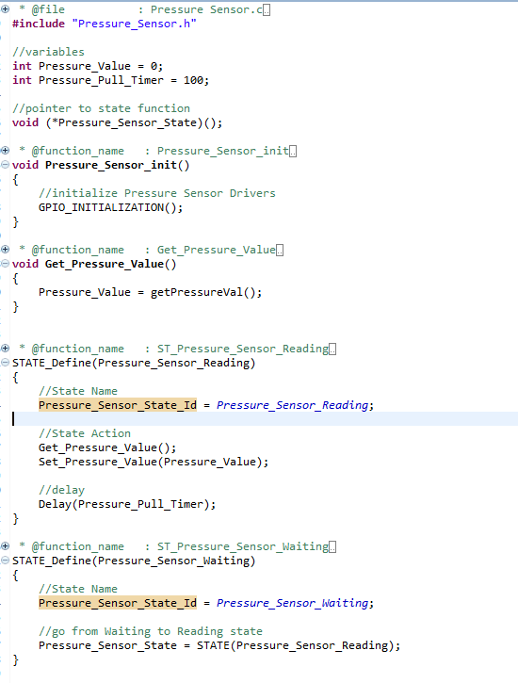

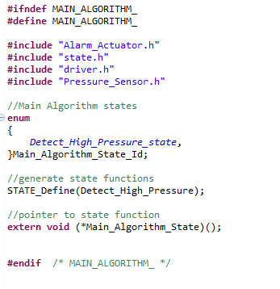

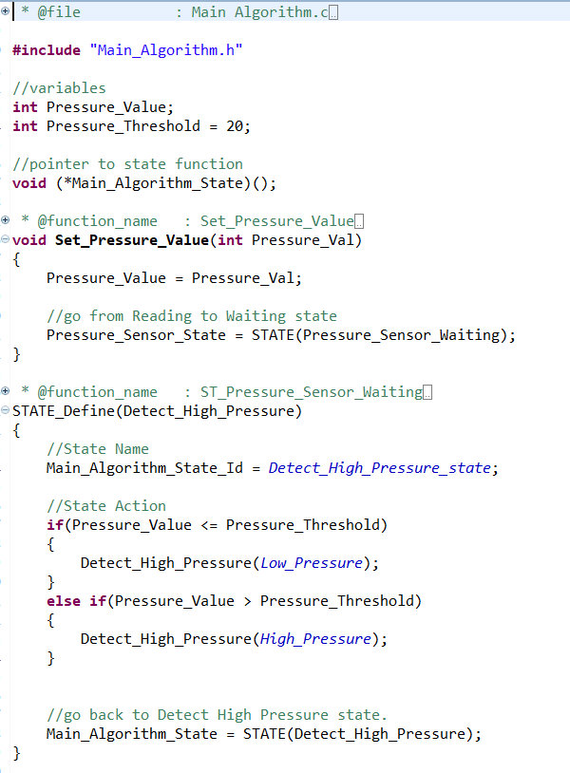

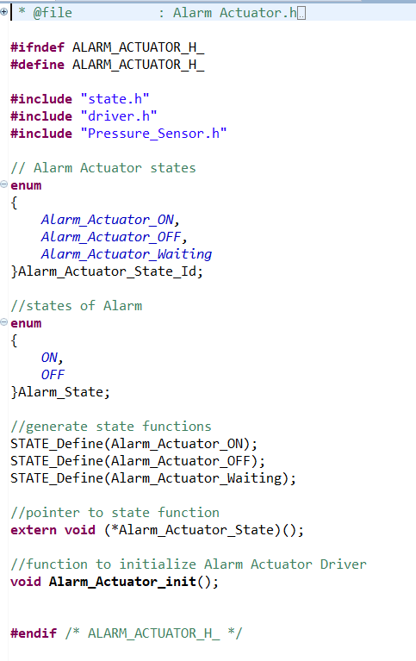

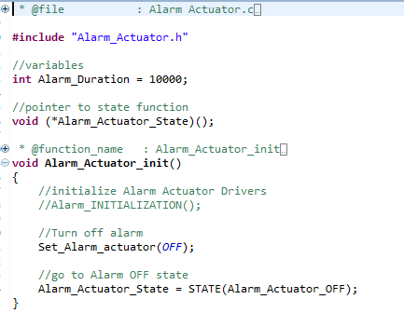

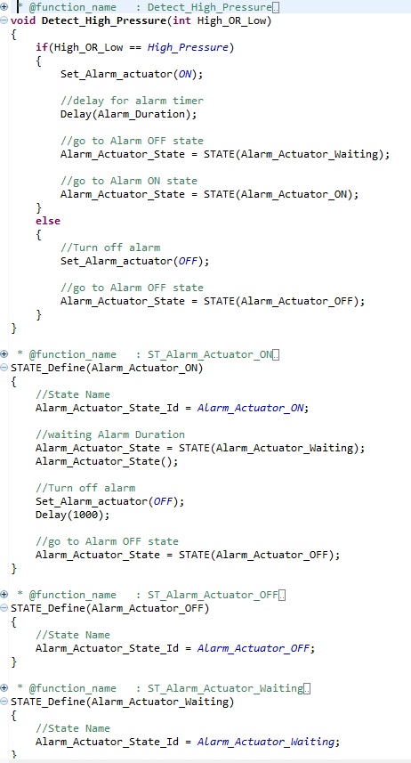

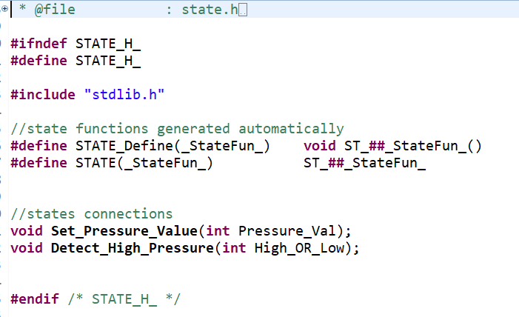

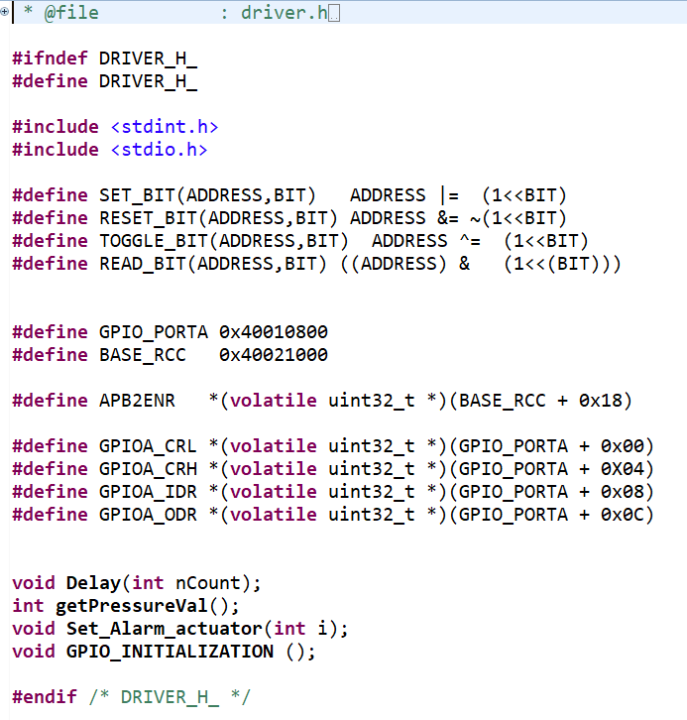

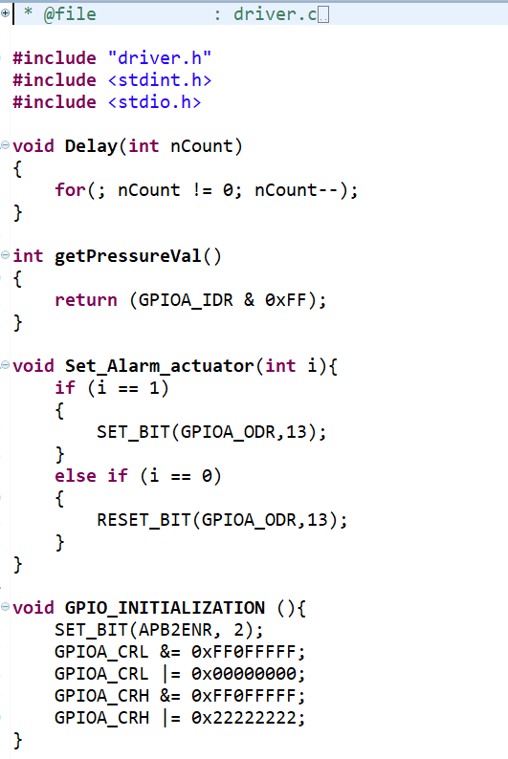

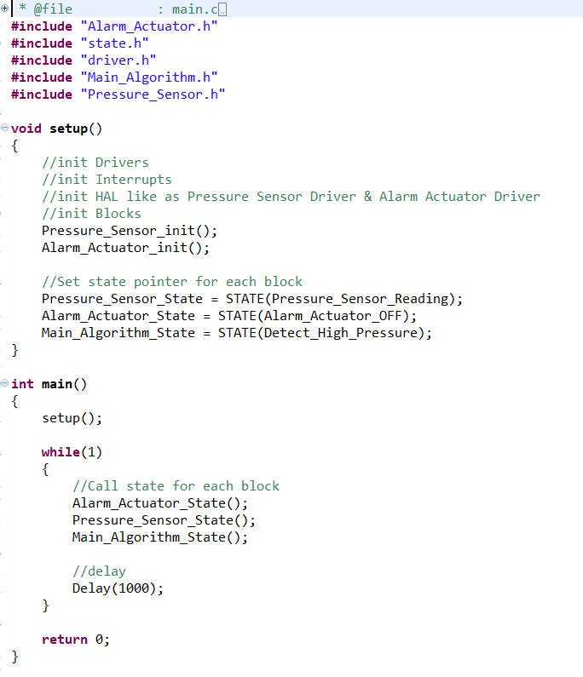

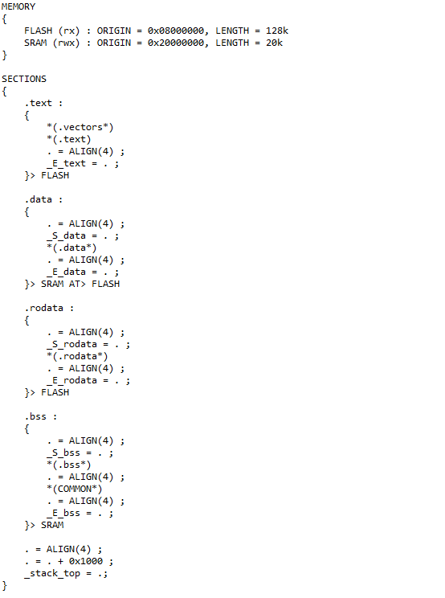

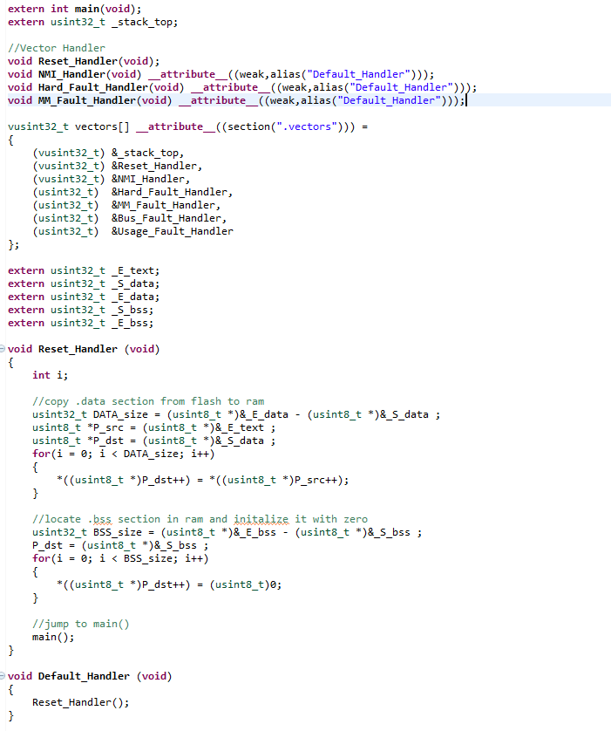

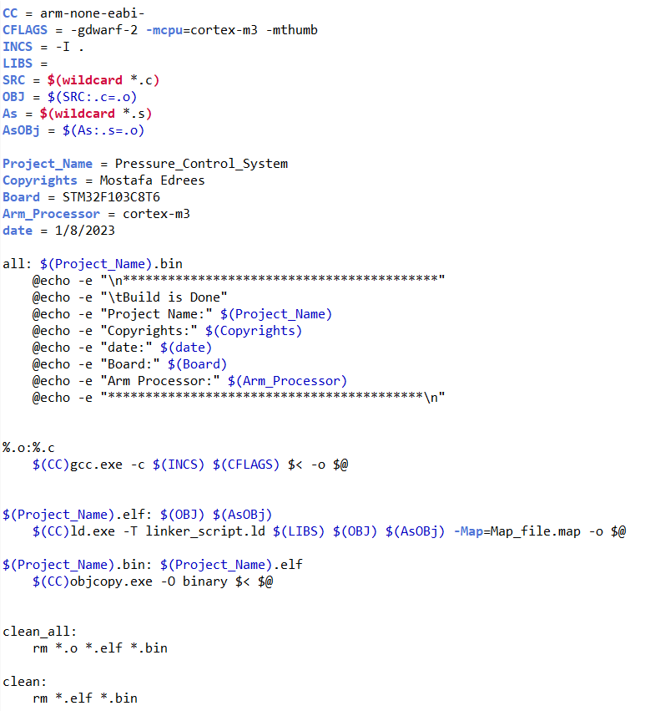

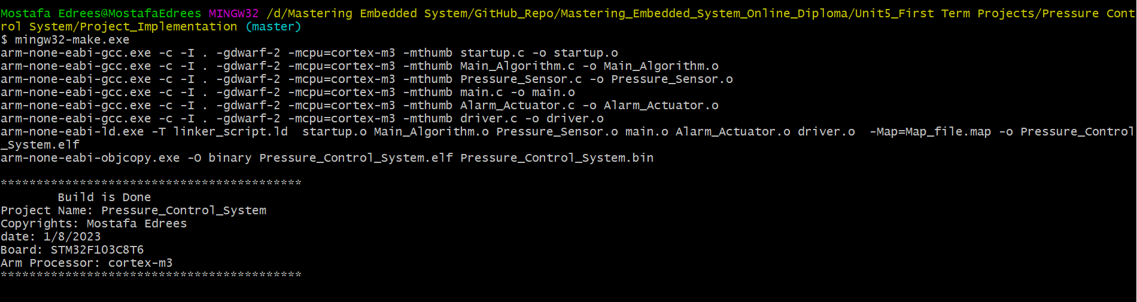**Build the project by using Makefile:**

**Link of GitHub Repository:**

[GitHub](https://github.com/MostafaEdrees11/Mastering_Embedded_System_Online_Diploma/tree/master/Unit5_First%20Term%20Projects/Pressure%20Control%20System)

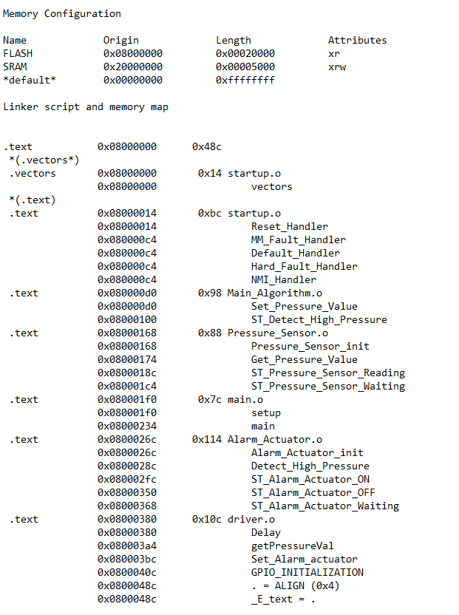

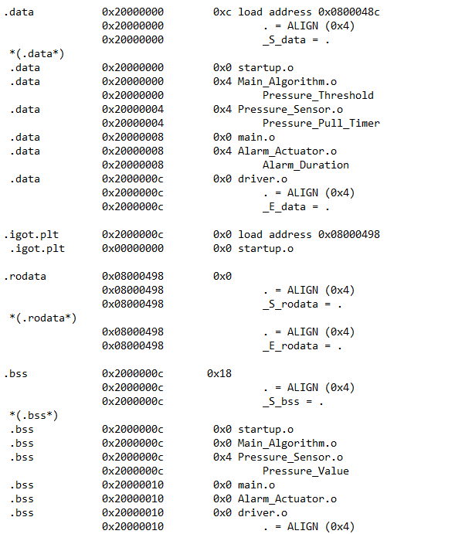

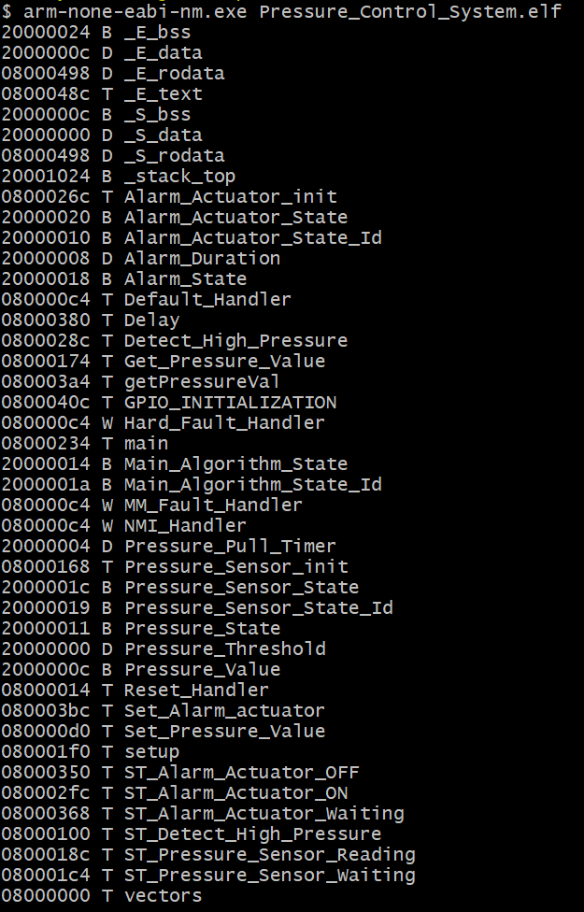**Symbols Table of executable file:**

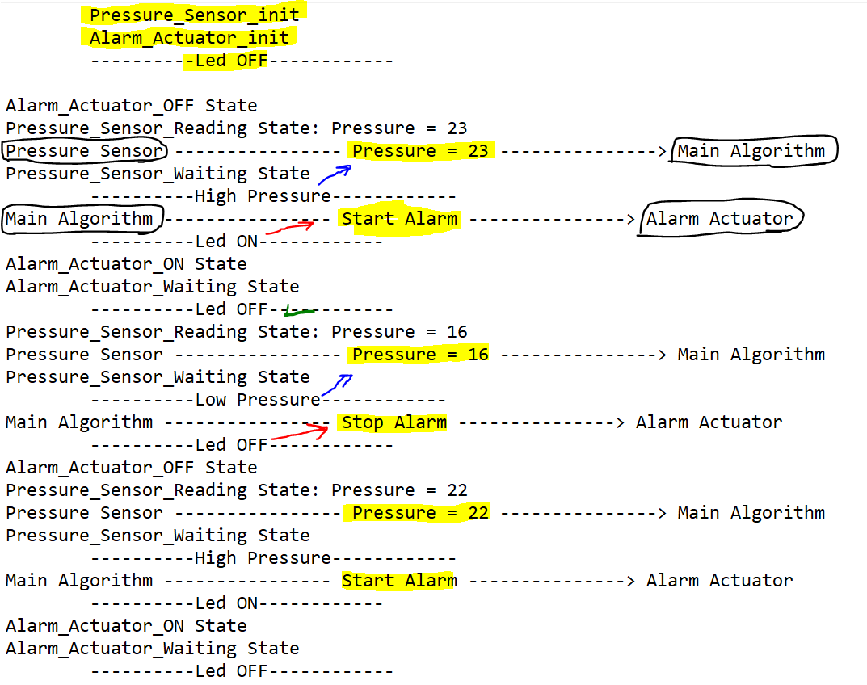

We will enter the pressure value by 8 switch buttons and these implement the binary number of pressure value.

**Case1:**

The Pressure Value is less than Threshold (20).

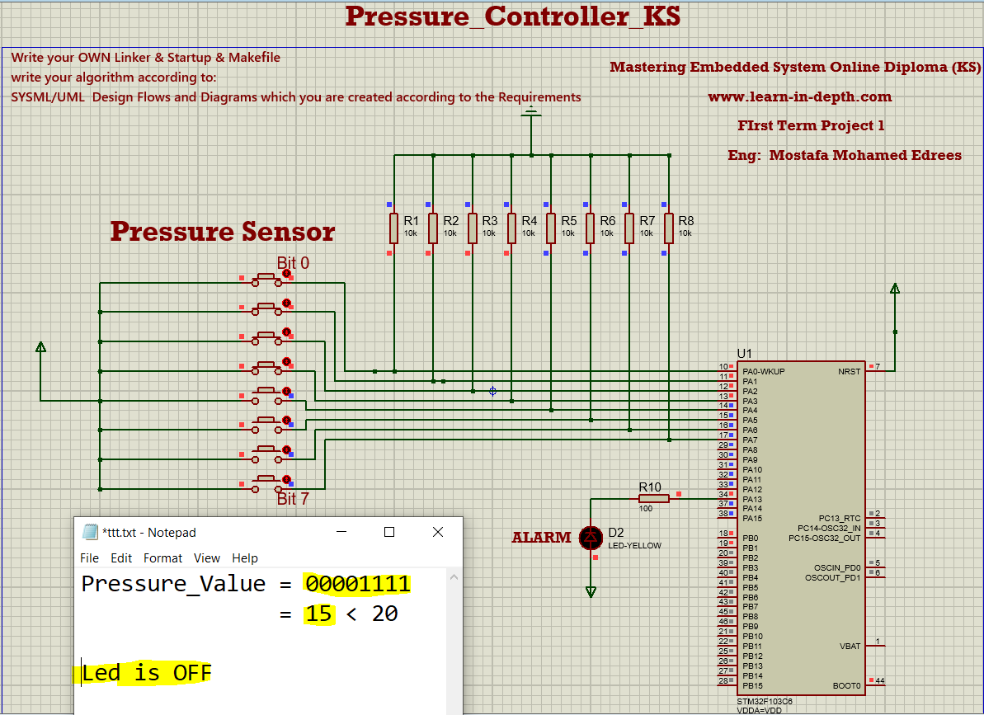

**Case2:**

The Pressure Value is more than Threshold (20).

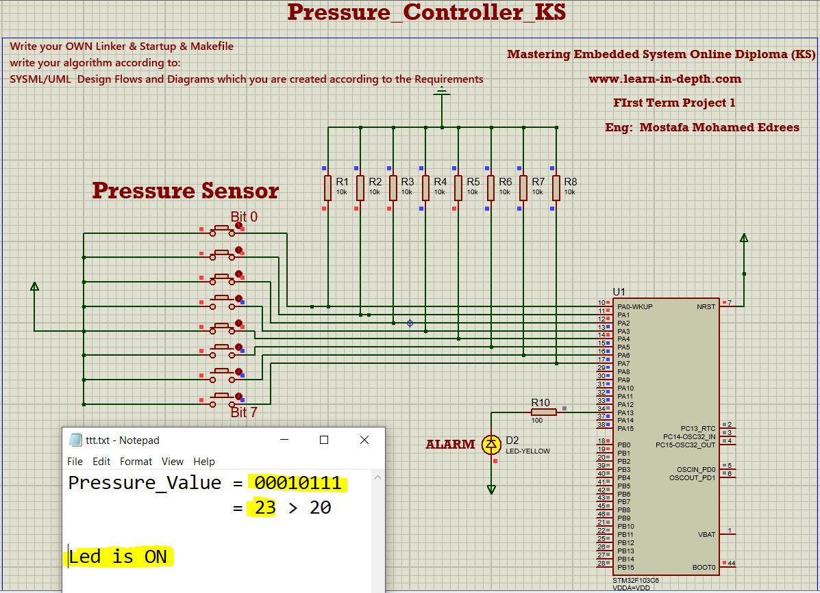

**You can see run of the project from here:**

[**Running Video**](https://drive.google.com/drive/u/2/folders/1-ubtekjkARF5dU45Q_bx7X0dgZyz0bcY)